June 3, 2017

CERTIFICATION

This is to certify that JOHN DOE has been employed with our company from April 2014 to May 2017 holding the position of Business Consultant.
This certification is being issued upon his request for whatever legal purpose it may serve him.
Issued this 3rd day of June 2017, Makati City.

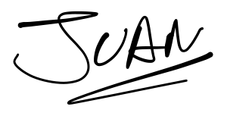

JUANA CLARISSE SANTOS
Acting Finance and Admin Manager

